Invest in Hoosier Health by
Increasing the Cigarette Tax
January 2019

An Unhealthy Story
- Indiana ranks 44th among states, down 3 places from
Alabama
41
42
Alaska
43
Ohio
44
Indiana
45
Mississippi
46
Arkansas
47
Tennessee
48
Louisiana
49
Kentucky
50
West Virginia
The Bottom 10
41st in 2017, in the percentage of people who smoke
- In the past two years, smoking in Indiana rose 6% while decreasing in many other states
- 22% of Hoosiers smoke (national average is 17%)
- This group generates $7.6B in health care costs – costs that we ALL pay

Indiana Business vs. Health Rankings
#
1
COST OF DOING BUSINESS
CNBC, America’s Top States for Business
BUSINESS
#
1
STATE INFRASTRUCTURE
CNBC, State of State Infrastructure Ranking
#
1
STATE REGULATORY ENVIRONMENT
Pacific Research Institute
#
5
PROPERTY TAX INDEX
The Tax Foundation
#
8
STATE TAX CLIMATE
Tax Foundation 2017 State Business Tax Climate Index
#
48
PUBLIC HEALTH FUNDING
HEALTH
#
44
PERCENTAGE OF SMOKERS
#
43
INFANT MORTALITY
#
42
CANCER DEATHS
#
41
OVERALL HEALTH
All ratings from
America’s Health Rankings 2018 Report
Smoking is a primary factor
for the low ranking.

The Cost to Employers
- An employee who smokes costs their employer $6,000 more per year* than an employee who has never smoked
- Tobacco users spend 175% more per person in inpatient, outpatient, and pharmacy costs and have 66% more medical/Rx claims
- Tobacco users spend 149% more per person in emergency room visits and are
320% more likely to have an emergency room visit
*2018 Ohio State University Study, Tobacco Control

Indiana’s Cigarette Tax
- Ranks 38th among states and is lower than all surrounding states (KY, IL, OH, MI)
- Has not increased in 12 years
- Helps fund the Healthy Indiana Plan (HIP)
- Additional funding would make HIP more secure for the future as federal funding is declining

A Partnership that Works
- Plan covers health care services for 250,000 low-income Hoosiers ages 19 to 64 who would have no other option for coverage
- Rewards Hoosiers for taking better care of their health through innovative design with a focus on wellness and personal responsibility
- Hospitals support HIP by paying the state a provider fee, the Hospital Assessment Fee (HAF)
- HAF is used by the state to leverage the federal matching dollars and funds a portion of the state’s Medicaid budget
- Hospitals are the only provider group paying fees to support HIP

Hospital Assessment Fee (HAF)
- Hospitals will pay over $1,000,000,000 in fees in State Fiscal Year (SFY) 2019. The fastest growing portion, $200M, supports HIP*
$1B
FEES PAID BY
INDIANA HOSPITALS
- Hospitals’ share is increasing at an unsustainable rate - 55% in the last two years (323% increase for the HIP portion)
- Many rural hospitals saw an increase of as much as 40-50% from SFY 2018 to 2019
*$800M is used to make low hospital reimbursement rates sustainable
Indiana Hospitals

How HAF Supports HIP
$
HOSPITAL
ASSESSMENT
FEE
State
Budget
$
$
$
Federal Government
90-100
%
FEDERAL
MATCH
Federal match is declining

A Healthy Investment
- Invest in the health of Hoosiers
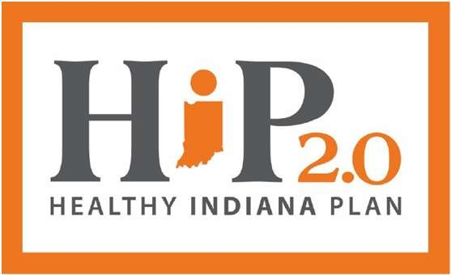
- Stabilize HIP 2.0, a national model program
- Reduce burden on hospitals as the sole funders of HIP
- Make Indiana’s economy more productive
- Enhance Indiana’s standing as a state that works
- Healthier people = a healthier, more competitive Indiana

